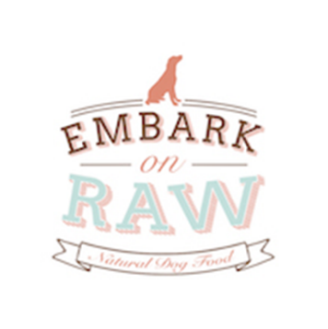

**Presents a**

**British Flyball Association**

**Sanctioned Limited Open Tournament**

At

**Barleylands**

**Southend Rd, Billericay**

**(Directions below, please follow these and not post code for Barleylands)**

**On Saturday 28th and Sunday 29th April 2018**

**(Closing Date 29th March 2018)**

**Online entries to the address below:**

Email: [wickfordwaggintails@gmail.com](mailto:wickfordwaggintails@gmail.com)

**Postal entries to:**

Sue Claydon

54 Elder Ave

Wickford

Essex

SS12 0LU

Tel: 07722 709386



**Tournament Rules and Regulations**

**Requests for specific days**

We will try to accommodate requests for specific days from teams, however this cannot be guaranteed. It is difficult to consider any requests until the running orders have been completed, 2 weeks prior to the event. Sadly, refunds will not be issued if we are unable to accommodate your request and you withdraw beyond the competition closing date.

(1) The Event Organizer(s) reserve the right to refuse entries and admission to the event of any persons not in good standing within the BFA.

(2) No person shall carry out punitive or harsh handling of a dog at the event.

(3) Bitches in season are not allowed near the show area. Mating of dogs is not allowed.

(4) A dog must be withdrawn from competition if it is:

(a) Suffering from infectious or contagious diseases.

(b) A danger to the safety of any person or animal.

(c) Likely to cause suffering to the dog if it continues to compete.

(5) It is the Teams Captain’s responsibility to ensure the team is available for their division and running order.

(6) The organizer(s) reserve the right to make any alterations they deem necessary in the event of unforeseen circumstances.

(7) All dogs enter the event at their own risk and whilst every care will be taken, the Event Organizer(s) cannot accept responsibility for damage, injury, or loss however caused to dogs, persons or property whilst at the event.

(8) All owners/handlers must clear up after their dogs. Anyone failing to do so will be asked to leave the venue.

(9) Current BFA Rules and Policies will apply throughout the Sanctioned Tournament

(10) If circumstances make it necessary to cancel the tournament, the organisers reserve the right to defray expenses incurred

**Please be aware of the following rules that apply to this venue;**

(11) All competitors MUST obey any “out of bounds” or restricted areas that are in place.

No ground level BBQs are allowed

(12) All competitors and visitors are responsible for their dogs and must make every effort to ensure they do not cause noise nuisance when not racing (or waiting to race) to the equestrian centre surrounding the venue and visitors to Barleylands.

**IT IS THE TEAM CAPTAINS RESPONSIBILITY TO ENSURE ALL MEMBERS OF THEIR TEAMS ARE AWARE OF THE RULES AND REGULAGTIONS FOR THIS SANCTIONED TOURNAMENT**.



**Entry form for limited open BFA sanctioned tournament**

**Saturday 28th and Sunday 29th April 2018**

**Entry Fee £40 per Team**

Declared times must be submitted in writing (or email) at least 14 days before the Tournament and must be at least a half second slower or faster than seed time. (BFA rule 4.4)

|  |  |
| --- | --- |
| TEAM NAME | Team BFA Number |
| 1. |  |
| 2. |  |
| 3. |  |
| 4. |  |
| 5. |  |
| 6. |  |

|  |  |
| --- | --- |
| Team Captain’s name: | BFA number: |
| Address: | |
| Telephone: | |
| Email: | |

Name of Head / Qualified / Provisional:

Judge

Measurer

Camping Pitches Required **______ Fri 27th April**

**______ Sat 28th April**

Number of teams entered ______ at £45 per team Total £

Number Camping Pitches ______ at £8 per pitch per night Total £

Total £...………Cheques payable to Sue Claydon (Entries will not be accepted without payment)

Bank details sort code: 07-02-46 Account number: 24182951

Please put team name as reference

Enclose SAE or email address for tournament information and running orders.

**From M25/A127**

M25 Stansted/Dartford Keep right at the fork and merge onto M25

At junction 29, take the A127 exit to Basildon/Southend

Take the A176 exit toward Basildon/Billericay (follow the brown and white tourist signs to BARLEYLANDS)

At the roundabout, take the 3rd exit onto South Wash Rd - Go through 1 mini roundabout

At the next mini roundabout, turn left onto Barleylands Rd (signposted BARLEYLANDS)

Continue to the end of Barleylands Road, going past the main entrance for BARLEYLANDS

At the end of this road turn right onto Southend Road A129, follow the signs for FLYBALL

The field entrance gate is on your right

**From A12 (Satnav’s might take you via Billericay High street, wouldn’t recommend this with caravans. Best to follow route below)**

Follow the A12 to the A130 in Essex. Take the A1114 exit

Continue on A130.

Take the A1245 exit towards Battlesbridge/Rawreth/Rettendon

At the roundabout, take the 1st exit onto A1245

At the roundabout, take the 1st exit onto A132

Continue onto Runwell Rd, going past Travel lodge and Toby Carvery

At the roundabout, take the 1st exit and stay on Runwell Rd, going down the hill past the Quart Pot pub on your right.

At the roundabout, take the 2nd exit (straight across the roundabout staying in the right hand lane) onto Golden Jubilee Way

At the next roundabout, take the 3rd exit onto London Road A129, at the traffic lights stay in the left hand lane and go straight across and continue on London Road A129 into Crays Hill.

Go past Harding Elms Road on your left and follow the FLYBALL signs on Southend Road, the entrance is on your left.

If you go past the Barleylands Farm Shop on your right, you have gone too far.

**PLEASE NOTE:**

**Due to Barleylands being a large site with many different entrances we have to keep the entrance gate locked at all times.**

**Please make sure you have you BFA card with you to gain entrance to the site as there will be someone on the gate to let you in.**

**This will be manned between 5pm - 8pm Friday 6.30am – 8am Saturday and Sunday**

**Out of these hours the gate will be locked, we will issue the code to Team Captains prior to the tournament.**

**PLEASE MAKE SURE THE GATES ARE CLOSED AND LOCKED AT ALL TIMES IN CASE TRAVELLERS GAIN ACCESS**

**We have sectioned off an exercise area within our tournament site, please use this to exercise your dogs and no other area of field within the Barleylands site as these are public areas. Dogs are to only be let off lead in the exercise area as there is an equine centre next to the tournament area.**

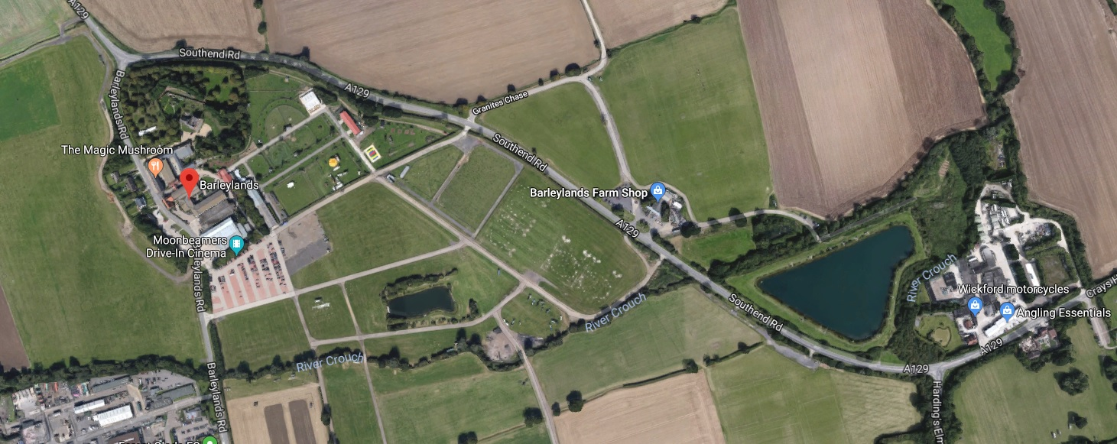

**RING**

**Day Parking**

**CAMPING FIELD**

**ENTRANCE/EXIT**

We are pleased to say that our Sponsor **Embark on Raw** will be at our show this weekend, they will be bringing a small amount of raw dog food, dog treats, Frozzy’s ice cream with them but if you would like to order any raw dog food in advance then they will bring it over for you.

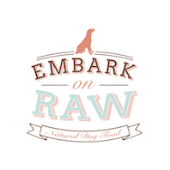

<http://www.embarkonraw.co.uk>

[info@embarkonraw.co.uk](mailto:info@embarkonraw.co.uk)

Unit 8F

Whitesbridge Farm Industrial Estate

Crays Hill

Billericay

CM11 2UL

Opening Hours: Friday 10am – 5pm

Saturday 10.30 – 3pm

To order raw dog food in advance please call Dave or Andrea on:

07816 783908 or

07791 570432