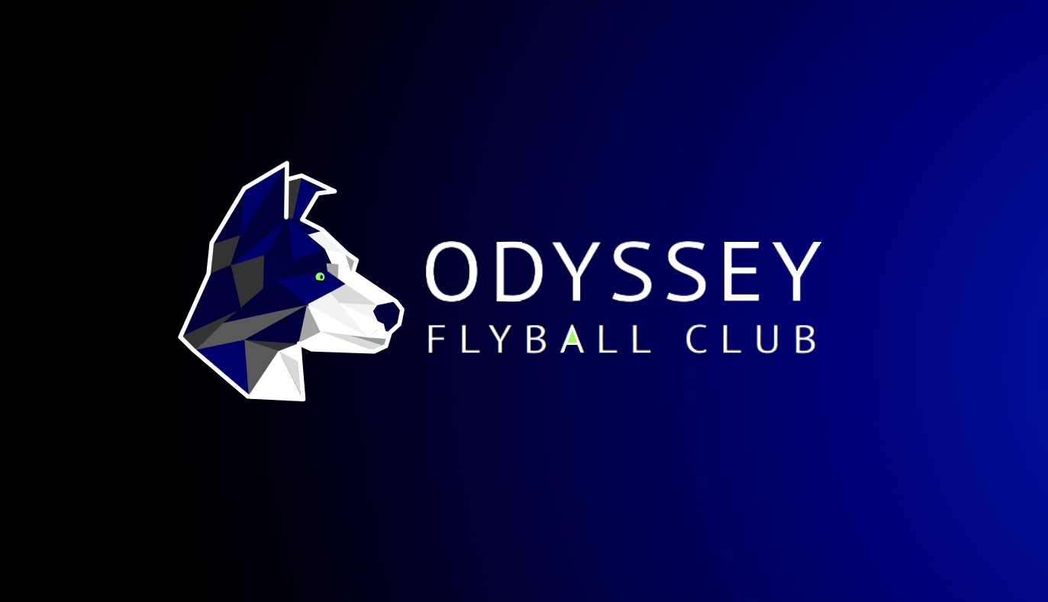

**PRESENTS**  
**A SANCTIONED OPEN TOURNAMENT**

**(Unlimited Team entry)**

**AT**

**Lydiard Park,**

**Lydiard Tregoze,**

**Swindon**

**SN5 3PA**

**ON**

Saturday 8th & Sunday 9th June 2024

**Online Entry**

Please click on the link to enter using our online form:

<https://forms.gle/5umm2VDNxCkBGZNh6>

(**Closing date for entries 26th April 2024)**

For further information contact:  
Mark Pitts  
Telephone: 07814 505153

E-mail: [odysseyflyball@gmail.com](mailto:odysseyflyball@gmail.com)

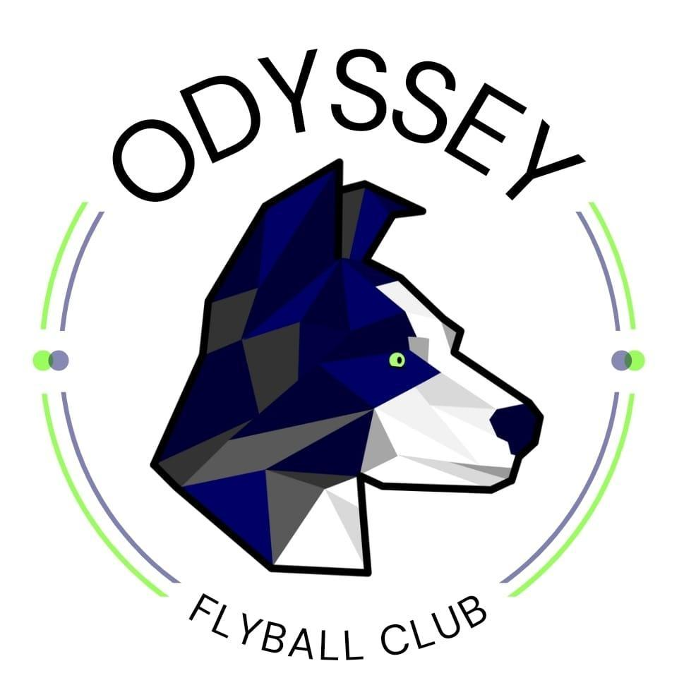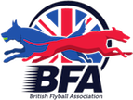

**Location -**(What3words - interviewer.bunks.springing)

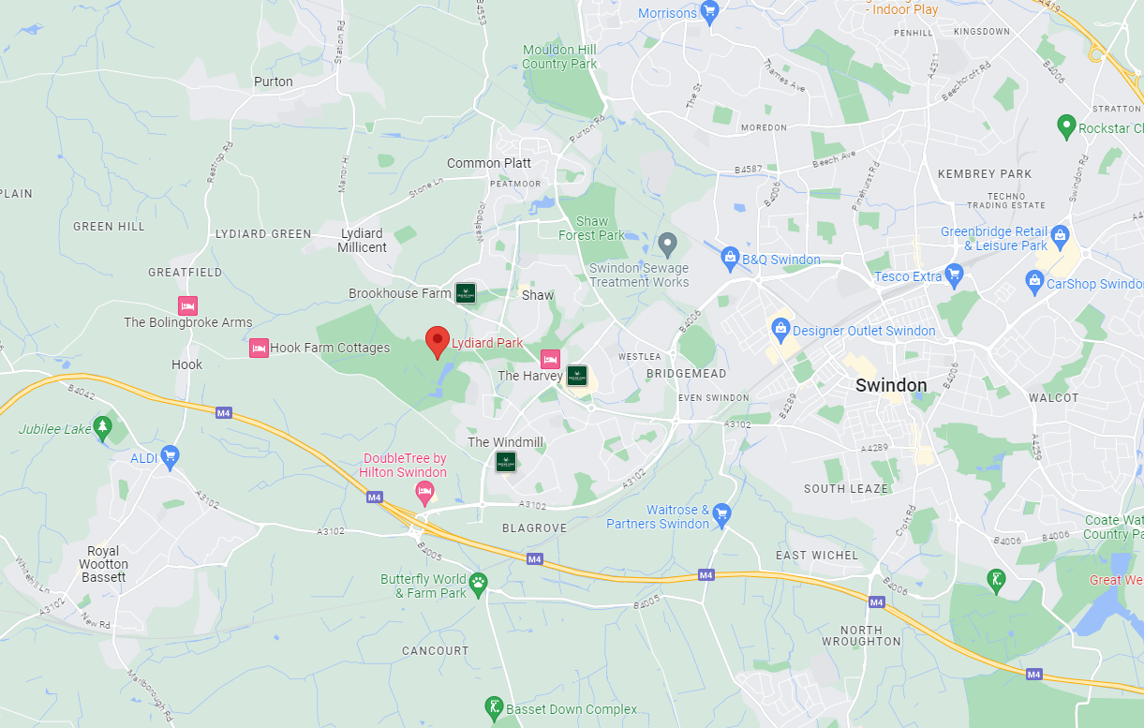

**Refreshments**   
There is a Cafe (200yd walk) on site which should be open over the weekend during day time hours.

**Entertainment**  
We will be hosting the Odyssey Olympics! This will involve competing as a team across various sports day style events, more information to follow! We would love as many teams to get involved in this as possible, it should be a good laugh and a bit of competitive fun outside the lanes!

**We look forward to seeing you all in June.**

**Odyssey Flyball Club**

**Tournament Rules and Regulations**

**Requests for specific days.**We will try to accommodate requests for specific days from teams, however this cannot be guaranteed. It is difficult to consider any requests until the running orders have been completed, 2 weeks prior to the event. Sadly, refunds will not be issued if we are unable to accommodate your request and you withdraw beyond the competition closing date.

(1) The Event Organizer(s) reserve the right to refuse entries and admission to the event of any persons not in good standing within the BFA.

(2) No person shall carry out punitive or harsh handling of a dog at the event.

(3) Bitches in season are not allowed near the show area. Mating of dogs is not allowed.

(4) A dog must be withdrawn from competition if it is:

(a) Suffering from infectious or contagious diseases.

(b) A danger to the safety of any person or animal.

(c) Likely to cause suffering to the dog if it continues to compete.

(5) It is the Teams Captain’s responsibility to ensure the team is available for their division and running order.

(6) The organizer(s) reserve the right to make any alterations they deem necessary in the event of unforeseen circumstances.

(7) All dogs enter the event at their own risk and whilst every care will be taken, the Event Organizer(s) cannot accept responsibility for damage, injury, or loss however caused to dogs, persons or property whilst at the event.

(8) All owners/handlers must clear up after their dogs. Anyone failing to do so will be asked to leave the venue.

(9) Current BFA Rules and Policies will apply throughout the Sanctioned Tournament

(10) If circumstances make it necessary to cancel the tournament, the organisers reserve the right to defray expenses incurred

**Please be aware of the following rules that apply to this venue;**

**Lydiard Park is a massive site (260-acres), so please make sure you keep an eye on any children you are responsible for, ensuring that they are always supervised by an adult.**

**All signs and health and safety information must be adhered to.**

**All competitors MUST obey any “out of bounds” or restricted areas that are in place.**

**No ground level BBQs are allowed.**

**All vehicles should keep to 5mph on the venue.**

**Please keep driving during the tournament to a minimum.**

**Please ensure generators are switched off between 11pm and 7am.**

**IT IS THE TEAM CAPTAINS RESPONSIBILITY TO ENSURE ALL MEMBERS OF THEIR TEAMS ARE AWARE OF THE RULES AND REGULATIONS FOR THIS SANCTIONED TOURNAMENT**.