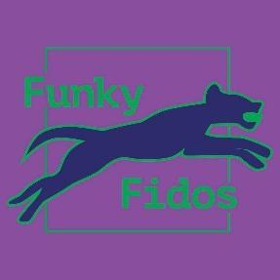

Funky Fidos Flyballers

Invite you to a

BFA Sanctioned Limited Open Competition

at
Peterborough Rugby Club,
33 Second Drove,
Peterborough,
Cambridgeshire,
PE1 5XA

on
Saturday 22nd July -
Sunday 23rd July 2023

Head Judge Paul Horton
Grass Block
Entries limited to
60 teams,
Closing date: Friday 23rd June 2023

Declared times must be submitted in writing (or email) at least 14 days before the tournament as per BFA rules
All times, seed or declared, except Div 1, are subject to the Division break-out rule.

Team Name |  | Team Number
(1)
(2)
(3)
(4)
(5)
(6)
(7)
Foundation Team name Foundation Single name |  | Foundation Team £35  Foundation single  £5
Team Captain name: | Email address:  Tel number:

HJ’s & QJ’s available:

Provisional judges available:

Measuring officials available:
Number of camping units @ £15 per night:

Friday ......................... Saturday ..........................

Payment £.............

Number of teams

...................... @ £45 each

Number of Foundation teams

………………. @ £35 each

Number of Foundation Singles

………………. @ £5 each

Total payment (inc camping if applicable)

£...........................

Email entries only to: funkyfidosflyballers@gmail.com

Payment Validates entry:
Please make payment via BACS

Funky Fidos
20-63-28
43193810

Enquiries via email only please

Show Rules and Regulations

- The Event Organiser(s) reserve the right to refuse entries and admission to the event of any persons not in good standing within the BFA.

- No person shall carry out punitive or harsh handling of a dog at the event.

- Bitches in season are not allowed near the show area. Mating of dogs is not allowed.

- A dog must be withdrawn from competition if it is :

- Suffering from infectious or contagious diseases.
- A danger to the safety of any person or animal.
- Likely to cause suffering to the dog if it continues to compete.

- It is the Team Captains responsibility to ensure the Team is available for their class and running order.
- No person shall impugn the decision of the head judge or judges.

- The organiser(s) reserve the right to make any alterations they deem necessary in the event of unforeseen circumstances.

- All dogs enter the event at their own risk and whilst every care will be taken, the Event Organiser(s) cannot accept responsibility for damage, injury, or loss however caused to dogs, persons or property whilst at the event.

- All owners/handlers must clear up after their dogs. Anyone failing to do so will be asked to leave the venue.

- If circumstances make it necessary to cancel the tournament the organisers reserve the right to defray expenses incurred by deducting such expenses from the entry fees received.

Current BFA Rules and Policies will apply throughout the Sanctioned Tournament.

