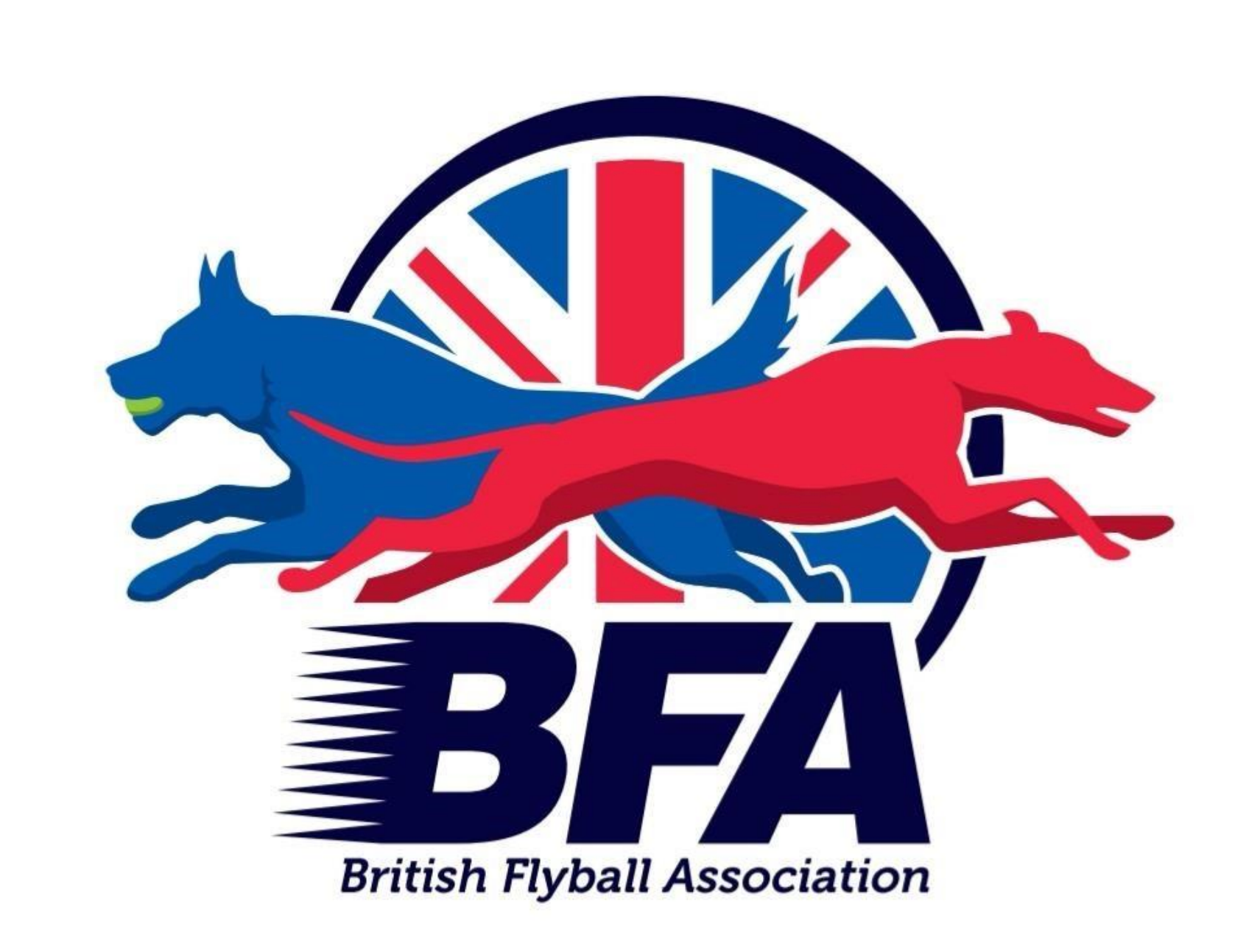

**Summary of BFA Rule Changes -June 2024**

**The BFA Constitution**

**Proposal 1 - The rewrite of our Constitution**

**Key Changes**

* + As from next year's AGM (2025) the committee will have six months to implement any new rules or rule changes.
  + Eligible members can now propose changes to the constitution at any time during the year. Proposals will go through a review process, once the process has been completed, they will be presented at the next AGM.
  + Changes to the process for calling and holding an EGM.

By far the most important change is that we now have a **Code of Conduct** which all members are required to follow.

**Conduct Requirements**

The following provides you with general guidance for your conduct as a member of the BFA:

**As a member you must**

* Always conduct yourself in an appropriate manner in flyball contexts.  For example (not an exhaustive list), when at flyball events such as competitions, demonstrations, and training sessions, in flyball related events such as AGMs and EGMs and also when using social media and other forms of communication. This always includes respectful communications verbally, electronically and in any written communication.
* Always exhibit appropriate behaviour towards others (both children and adults).
* Follow the BFA Constitution and Rules of Racing and interpret them in the spirit of promoting and supporting the flyball community and the sport.
* Follow ***all BFA policies and procedures published on the BFA website.*** You are expected to familiarise yourself with and comply with these policies. *(Social Media, Data Protection, Disability Discrimination, Safeguarding*)

Finally the Constitution Working Party really would like to emphasise that our constitution is now a “living, breathing” document that will be kept under constant review and development to ensure it is fit for purpose and as such they would like to encourage any member interested in joining this process, to get in touch by emailing the committee liaison [hilary.larkham@bfa.email](mailto:hilary.larkham@bfa.email)

**Rules of Racing**

*Please be aware that the following summary and guidance simply describes the rule changes and their effect, it is not intended to override or supersede the rule book.*

### Proposal 2 - Spelling mistake - No further communication required

## Proposal 3 - Withdrawn

## Proposal 4 - Not voted in

## Proposal 5 -Change of wording leg to heat - No further communication required

## Proposal 6 - Jumps - The edges and the inside faces of the jumps must be white. Stickers are still allowed to be placed on the outside and baseboard of the jumps, but not the inside faces.

## The Judges Boards advice is for all Tournament Organisers to ensure no stickers are on the inside of the jump wings.

## Proposal 7 - Not voted in

## Proposal 8 - Amending C2 forms after racing has started - If a team captain spots there is a minor administrative error on the C2, that does not affect the result of the racing, they can point out this error to the divisional judge, who must agree that the error can be corrected. The Team Captain may then approach the tournament Head Judge, who is the only person allowed to amend the C2 form, whilst racing is still in progress. Once racing has finished the C2 forms cannot be changed.

## The Judges Board have agreed that any amendments that are made on the C2 are initialled at the side of the amendment by the Head judge.

## Proposal 9 - Balls - A ball of any colour, material or size that’s suitable for the comfort and welfare of the dog may now be used in Open racing instead of a tennis ball. When it’s dead-dropped, bounced or rolled the ball must behave in the same way as a standard tennis ball and must be projected the designated distance from the box, when the box is triggered. The ball must not contain a noise making device and must not be covered in real or faux fur.

## The Judges Board have confirmed that during box checking any new ball found will be checked to ensure that it travels the distance stipulated in the regulations, within the rule book. Foam balls are to be checked for missing parts and removed from play if not whole.

## Proposal 10 - Boxes entering the ring - The warm up period for racing will start when both incoming boxes have been placed into position in a timely manner. If the divisional judge feels that an incoming team is taking too long to place their box the judge may start the warm up time prior to the boxes being placed.

## Members should make their Divisional Judge aware of any scheduling difficulty or conflicts which may cause a delay BEFORE their race is due to begin.

## The Judges board’s advice is that the two minute warm up will start once the last box is in place. They have reiterated that incoming teams cannot take too long to place their box and that the judge may start the warm up time prior to the last box being in place. If judges believe teams are taking unreasonable amounts of time then they will speak with the team captain and advise the head judge that warm ups will be started prior to their box being placed.

## Proposal 11 - Not voted in

## 

## Proposal 12 - WFC - A team is deemed to be WFC as soon as they notify the divisional judge, or as soon as they are unable to run 4 dogs in a race. If a dog is injured and has to be withdrawn, so that a team is unable to field a full complement, the team will immediately become WFC and will remain WFC for the remainder of the competition, even if the dog returns to race later.

## Proposal 13 - Not voted in

## Proposal 14 - Not voted in

## Proposal 15 -Treats - Treats must be kept secure in the ring at all times. A dog can be treated either directly from the hand or from a suitable receptacle as long as the treats do not come into contact with the floor. If the rule is not adhered to a warning will be issued in the first instance and if further offences occur the team shall forfeit the next leg.

## Please See the rule book for more information on what is considered to be a suitable receptacle.

## Proposal 16 - Box checking - In addition to the head judge, nominated qualified judges, who are experienced and capable of carrying out the required checks, will now be allowed to do so.

## Proposal 17 - Judges from other associations - Experienced, qualified judges from other flyball organisations must pass the novice judges exam before qualifying to judge in BFA competitions. They must also be supervised once for a full division on each of the ring party duties, and twice for a full division judging whilst being supervised by a head judge. Evidence of judging experience will be required on application.

## Proposal 18 - Supervising judges - Must be within the ring and cannot be undertaking ring party duties at the same time as supervising a novice judge.

## Proposal 19 - Judges signalling to stop a heat - If it is necessary to stop a heat, the Divisional Judge shall use a whistle, either electronic or a referee’s whistle. The Judge will also give clear hand signals by raising both arms to indicate the race has been stopped.

## The Judges Board have confirmed that arms are to be at a comfortable level for teams to see (not over the head, can be waist high), the judge does not need to leave arms out for a long period of time and if the judge is unable to use their arm to inform the teams in advance and let them know how they will communicate the end of a heat.

## Proposal 20 - Scribes watching the run back area -Scribes are responsible for recording all required data correctly on the C2 form. During racing they should also be watching the run-back area for dog interference.

## The Judges Board have confirmed that if the scribe witnesses a dog from the opposing team crossing into the run back area and stops the team from completing their heat they should indicate to the judge, the judge will stop the race and converse with the scribe as to what happened, the judge will then determine if this was interference and needs to be recorded on the C2 or whether it is distraction and needs to be re-run.

## 

## Proposal 21 - Measuring officials can qualify on Ulna only - Where Provisional Measuring Officials have completed the requirements for Ulna measuring, submitted their qualification records and been passed by the Judges Board, they will become qualified for this expertise of measuring. They will be allowed to Ulna measure at competitions, but will not be qualified to complete the Withers measurements as a qualified measurer.

## Proposal 22 - Not voted in

## Proposal 23 - Loss of points - What do we as members need to do? All you need to do is carry on as you normally would. Rule 6.5 states - The Team Captain or designated representative is to ensure the C2 is completed correctly. This rule proposal was to allow the stats team more flexibility in being able to award points where mistakes on the C2 were made.

## Proposal 24- Withdrawn

## Proposal 25 - Adding additional awards - BFA awards for dogs reaching 3,000 and 15,000 points have been reinstated. The awards will be backdated at no cost to the membership.

## In order to receive your backdated certificate please ask your team captain to email your name, your dog’s name and BFA number, and the date and competition at which the award was achieved to [awards@bfa.email](mailto:awards@bfa.email) and the certificate will be sent to the next competition that you are attending.

## Due to the volume of certificates likely to be requested, please be patient as the official producing the certificates will be working through the requests as quickly as possible.

## Proposal 26- Withdrawn

## Proposal 27 - Foundation racing. The winner of foundation racing will be the team which achieves the highest percentage of clean runs, out of those available to the team, rather than the count of clean runs achieved by the team.