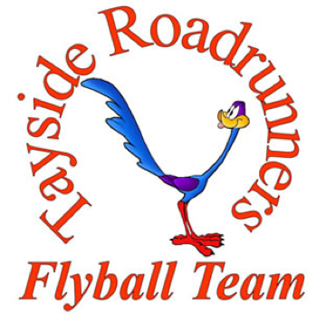
present a
Sanctioned Competition

Limited Open Flyball Tournament (54 Teams)
at
Camperdown Country Park, Dundee, Scotland, DD2 4TF

22nd & 23rd July 2017
(Closing date 23rd June 2017)

Featuring: Open Classes and Starters
Camping available on site for Friday & Saturday night
Electronic entries accepted:
https://www.iball4flyball.co.uk/t/TRR_Jul17

Paper entries to: Alan Wood, 9 The Logan, Liff, Dundee, Angus, DD2 5PJ
Contact Alan Wood: Phone: 01382 580443 / 07968210975
Email: awood@taysideroadrunners.co.uk

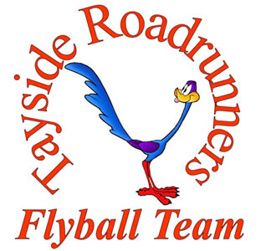

Entry Form for BFA sanctioned Limited Open Tournament (54 Teams)
Camperdown Country Park, Dundee
22nd & 23rd July 2017
(Closing date for entries is 23rd June 2017)

Entry Fee £35 per team

Declared times must be submitted in writing or email at least 14 days before the tournament & must be at least one second slower than seed time (BFA Rule 4.5).
N.B. Team break out time is half a second faster then declared time (5.17(l)). Declared times faster than the seed time are not subject to the team break out rule. All times, seed or declared, except Div 1, are subject to the division break out rule.

 | Team Name | Team BFA Number
1
2
3
4
5
6
7

Team Captain:
Address:
Tel No:
Email:

Electronic entries accepted via:
https://www.iball4flyball.co.uk/t/TRR_Jul17

Alternatively, please complete and return forms and payment - See over for Starters Entry, Camping Booking and Financial Information.

Please include an email address for running orders, which will be sent to team captains approximately one week prior to the event.

Starters Entry Form
Camperdown Country Park, Dundee
22nd & 23rd July 2017
(Closing date for entries is 23rd June 2017)

Entry Fee £25 per Starters Team

Starters Team Name
1
2
3
4
5
6
7

Financial Information & Camping Booking

Number of Open Teams entered | _______ | @ £35 per team | = £
Number of Starter Teams entered | _______ | @ £25 per team | = £
Number of Camping Pitches (Friday) | _______ | @ £8 per pitch | = £
Number of Camping Pitches (Saturday) | _______ | @ £8 per pitch | = £
 |  | TOTAL | = £

Electronic entries accepted via:
https://www.iball4flyball.co.uk/t/TRR_Jul17

Alternatively please return completed forms along with payment (cheque) to:
Alan Wood, 9 The Logan, Liff, Dundee, Angus, DD2 5PJ.

Cheques enclosed for £_________ (payable to Alan Wood)
Email address for tournament info and running orders: _________________________
Directions to Camperdown Country Park, Dundee, Scotland, DD2 4TF

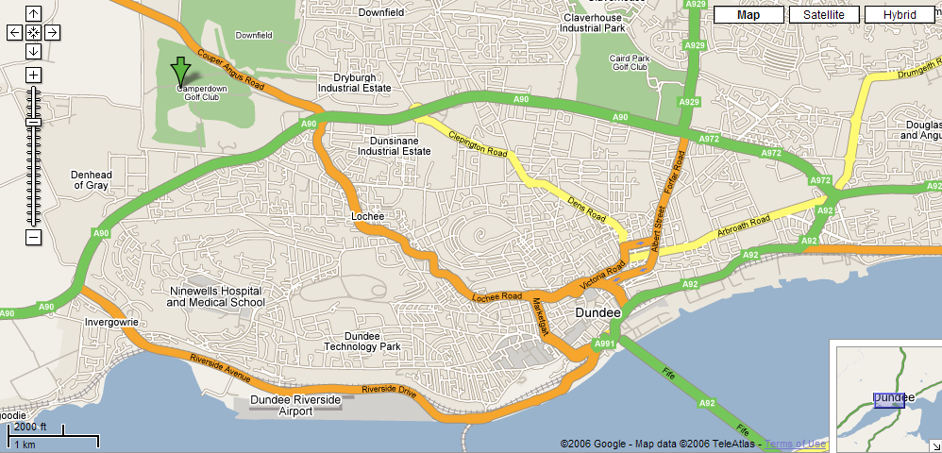

Reached by Dundee Outer Ring Road - Kingsway (A90). Take slip road for Coupar Angus Road (A923), then turn left into Camperdown Country Park.

Nearby (walkable) fast food outlets available include KFC and McDonalds, as well as a Premier Inn with restaurant/bar

Show Rules and Regulations

- The tournament organiser(s) reserve the right to refuse entries and admission to the event of any persons not in good standing with the B.F.A.
- No person shall carry out punitive or harsh handling of a dog at the event.
- Bitches in season are not allowed near the show area. Mating of dogs is not allowed.
- A dog must be withdrawn form competition if it is:
  - Suffering from infectious or contagious diseases.
  - A danger to the safety of any person or animal.
  - Likely to cause suffering to the dog if it continues to compete.
- It is the Team Captains responsibility to ensure the team is available in their class and running order.
- The organiser(s) reserve the right to make any alterations they deem necessary in the event of unforeseen circumstances
- All dogs enter the event at their own risk and whilst every care will be taken, the event organiser(s) cannot accept responsibility for damage, injury, or loss however caused to a dog’s, persons or property whilst at the event.
- All owners/handlers must clean up after their dogs. Anyone failing to do so will be asked to leave the venue.
- If circumstances make it necessary that the tournament in cancelled, the organisers reserve the right to defray expenses incurred by deducting such expenses from the entry fees received.
- B.F.A. rules and policies operative at the closing date for entries will be apply throughout the sanctioned tournament.

