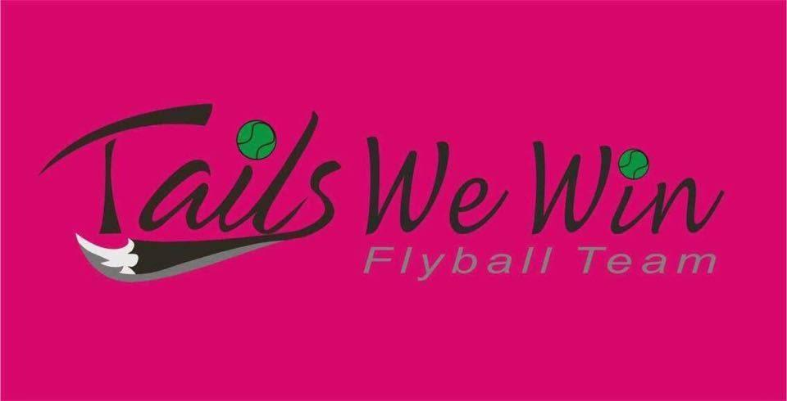

Are pleased to announce we are hosting a
British Flyball Association Sanctioned Limited Open Tournament!

On the 16th and 17th of September 2017
Held At:
Paws in the Park, Detling Showground,
Kent, ME14 3JF

Closing date for entries: 18th August 2017
Entry Limit: 48 teams
Camping 1 night £15.00
Camping 3 nights £25.00
For any further information please contact Joe Mitchell;
Tel 07528820620
Email mitchelljoe_13@hotmail.com

Please review the Special Notes and Show Rules below.

Entry Form for a BFA sanctioned tournament
Closing date: 18th August 2017
Declared times must be submitted by email at least 14 days before the tournament and must be at least half a second faster or slower than seed time. (BFA rule 4.4)
Team breakout time is half a second faster than declared time. All times, seed or declared, except Division 1, are subject to the division breakout rule. (BFA rule 5.17(I)
 | Team Name | BFA Number
1
2
3
4
5
6
7

Team Captain
Email
Address
Telephone

Judges (Please state if provisional or qualified)

Entry Summary
Number of open teams entered at £40.00 each: |  | Total:  £
Number of camping pitches required £15.00 for 1 night £25.oo for 3: | Thursday:  Friday:  Saturday: | Total:  £

Number of personnel passes required:

Entries via iBall on http://www.iball4flyball.co.uk/events/bfa-tourn.php?event=TWW_Sep16

OR

Postal Entries to: Helen Welch
61 Longfield Ave
Wallington
Greater London
SM6 7AZ

Please make all cheques payable to: Tails We Win Flyball Team

Special Notes:
- Due to this being a public event and space limited, camping needs to be pre booked and paid for and passes requested by 21st of August. Any requests received after this date cannot be guaranteed.
- On show dates all vehicles with passes must be in their allocated car parks by 8.00am vehicles arriving after 8.00am will be required to park in the main car park and normal entrance prices will apply.
- We are required to supply names of all personnel requesting passes, personnel passes (1 per exhibitor) will be provided free of charge (extra passes for those people not exhibiting can be pre-booked through the website or on the gate on arrival on the show) passes are limited to a maximum of 6 passes per team .
- Camping passes will be issued to exhibitors who will be camping for the show.
- Car passes will be issued to those people who will be attending during show days. Passes are to be displayed on entry to the event and at all times in the car windscreen security at the show is very important. No one will be allowed access in or out of the show ground without their pass.

Show Rules:
- The event organiser(s) reserve the right to refuse entry and admission to the event of any person not in good standing with the BFA.
- No person shall carry out punitive or harsh treatment of a dog whilst at the event.
- Bitches in season are not allowed near the show area.
- Mating of dogs is not allowed at a sanctioned BFA event
- A dog must be withdrawn from competition if it is:
  - Suffering from an infectious or contagious disease
  - A danger to the safety of any person or animal
  - Likely to cause suffering to the dog if it continues to compete
- It is the team captain’s responsibility to ensure that the team is available for their races, running order and ring party duties on time.
- The organiser(s) reserve the right to make any alterations they deem necessary in the event of unforeseen circumstances.
- All owners and handlers enter their dogs at their and their pets own risk and whilst every care will be taken the event organiser(s) will not accept responsibility for damage, injury or loss, however caused to dogs persons or property whilst at the event.
- All dog owners/handlers must clean up after their dogs, anyone failing to do so will be asked to leave the venue.
- BFA rules and policies will apply throughout the sanctioned tournament .
- All teams entering the show are expected to assist with ring party duties as required by the event organiser(s).
- Dogs must be kept in control at all times whist attending the event. Please be sure to clean up after your dog/s
- In the event that the tournament is cancelled, refunds will be made to teams once all necessary expenses have been met.

