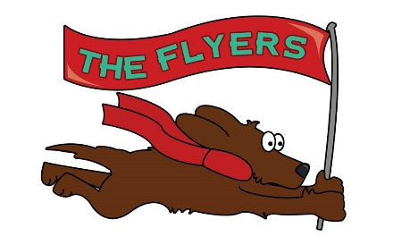

Extreme Racers and High Flyers Flyball Teams invite you to a
British Flyball Association Sanctioned Limited Open Tournament to be held indoors on

Saturday 1st July 2017
&
Sunday 2nd July 2017
(Limited to 96 Teams)

at
Newark Showground
Lincoln Road
Newark-on-Trent
NG24 2NY

The closing date for entries is 1st June 2017

Racing on both days will be run in a round robin, staggered format, ensuring that dogs have a minimum of 40 minutes break between each of their races.

Camping is available at the venue

For further information, please contact:
Ryan Mills (0114) 2218821, 07795 023692
Email extremeracersflyball@gmail.com

ENTRY FORM
Limited Open Sanctioned Tournament
1st & 2nd July 2017 at Newark Showground, NG24 2NY

Declared times must be submitted in writing (or email) at least 14 days before the tournament and must be at least half a second faster or slower than seed time (Rule 4.4).
Team break out time is half a second faster than declared time (5.17(l)).
All times, seed or declared, except Division 1, are subject to the Division break out rule.

 | Team Name | BFA number
1
2
3
4
5
6
7

Team Captain
Address
Email address
Telephone number(s)

Head/Qualified judges available
Provisional judges available
Measuring officials available

Camping units @ £10 per night | Thursday | Friday |  | Saturday |  | Sunday | Total
Total due for camping |  |  |  |  | £
Total due for team entry @ £45 per team |  |  |  |  | £
Total amount due |  |  |  |  | £
Please make all cheques payable to Extreme Racers Flyball Teams.
Please email extremeracersflyball@gmail.com if you would like details of how to pay electronically.

Please send postal entries to:
Ryan Mills
61 Northern Avenue
Sheffield
S2 2JA

Online entries:
https://1drv.ms/xs/s!AnAI25CHWizsgwXMuleqHY8u9Xp_

SHOW RULES AND REGULATIONS

- The Event organiser(s) reserve the right to refuse entries and admission to the event of any persons not in good standing within the BFA.

- No person shall carry out punitive or harsh handling of a dog at the event.

- Bitches in season are not allowed near the show area. Mating of dogs is not allowed.

- A dog must be withdrawn from competition if it is:

  - Suffering from infectious or contagious diseases;
  - A danger to the safety of any person or animal; or
  - Likely to cause suffering to the dog if it continues to compete.
- It is the Team Captains responsibility to ensure the Team is available for their class and running order.

- No person shall impugn the decision of the head judge or judges.

- The organiser(s) reserve the right to make any alterations they deem necessary in the event of unforeseen circumstances.

- All dogs enter the event at their own risk and whilst every care will be taken, the Event Organiser(s) cannot accept responsibility for damage, injury, or loss however caused to dogs, persons or property whilst at the event.

- No alcohol can be consumed within or around the ring.

- All owners/handlers must clean up after their dog. Anyone failing to do so will be asked to leave the venue.

- If circumstances make it necessary that the tournament is cancelled, the organisers reserve the right to defray expenses incurred by deducting such expenses from entry fees received.

- On and around the flyball field a strict speed limit (5 mph) will apply and vehicle movement restrictions will apply throughout the event.

- BFA rules and policies will apply throughout the Sanctioned Tournament.

